Bug Report

# Bug1: Verification Mail sent after creating an account doesn’t have a verification mail

Requirement: 1

Test case: 1

Steps:

1. Enter a First Name that starts with Capital Letter
2. Enter a Last Name that starts with Capital Letter and is not equal to first name
3. Enter a valid Gmail address that doesn’t exist in the system
4. Enter a password that has a capital letter, a small letter, a special character
5. Click Submit

Expected Behavior:

1-After click Submit, Check verification mail sent

2- Click on verification link on Verification Mail sent

3- Verify user login correctly

Actual Behavior:

1. verification mail sent
2. no verification link exist in the verification mail

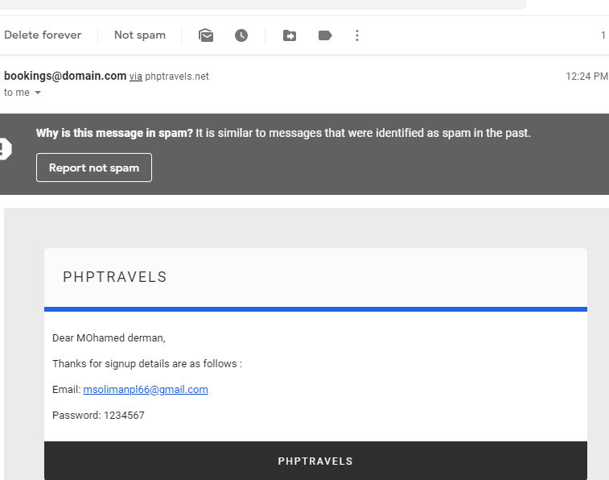

# Bug2: Account created successfully although First Name doesn’t start with Capital Letter

Requirement: 1

Test case: 2

Steps:

1. Enter a First Name that doesn’t start with Capital Letter
2. Enter all other fields according to requirements 2 to 5
3. Click Submit

Expected Behavior:

1-Validation Message appears indicating that First Name doesn’t start with Capital Letter

Actual Behavior:

Account Created Successfully

# Bug3: Account created successfully although Last(First) Name doesn’t start with Capital Letter

Requirement: 1

Test case: 2,3

Steps:

1. Enter a Last(First) Name that doesn’t start with Capital Letter
2. Enter all other fields according to requirements 2 to 5
3. Click Submit

Expected Behavior:

1-Validation Message appears indicating that Last(First) Name doesn’t start with Capital Letter

Actual Behavior:

Account Created Successfully

# Bug4: Account created successfully although First Name equal to Last Name

Test case: 4

Requirement: 2

Steps:

1. Enter a Last Name that starts with Capital Letter
2. Enter all other fields according to requirements 2 to 5(First and last name are equal)
3. Click Submit

Expected Behavior:

1. Validation Message appears indicating that Last Name Should Be Equal to First Name

Actual Behavior:

Account Created Successfully

# Bug5: Account created successfully although Password doesn’t contain a capital letter or a small letter or a special character

Test case: 6

Requirement: 4

Steps:

1. Enter invalid password that contains any 10 numbers
2. Enter all other fields according to requirements 2 to 5
3. Click Submit

Expected Behavior:

After click Submit, Check verification mail sent

1-Validation Message appears indicating that the password is invalid

Actual Behavior:

Account Created Successfully

# Bug6: Account not created successfully when Password is shorter than 6 characters

Test case: 6

Requirement: 4

Steps:

1. Enter invalid password that contains any 5 numbers
2. Enter all other fields according to requirements 2 to 5
3. Click Submit

Expected Behavior:

1-After click Submit, Check verification mail sent

2- Click on verification link on Verification Mail sent

3- Verify user login correctly

Actual Behavior:

Account not created successfully and a validation message appears that password is less than 6 chars